Team BengalSub’s of Autonomous Underwater Vehicle Hangor 2.0

Author 1, Author 2, Author 3, Author 4, Author 5, Author 6, Author 7, Author 8, Author 9, Author 10, Author 11, Author 12, Author 13, Author 14, Author 15

Abstract—This electronic document is a “live” template and already defines the components of your paper [title, text, heads, etc.] in its style sheet. *CRITICAL: Do Not Use Symbols, Special Characters, Footnotes, or Math in Paper Title or Abstract. (Abstract)

Competition Strategy

Core Strategy
This year, Hangor Autonomous Underwater Vehicle (HAUV)’s competition strategy emphasizes reliability, flexibility, and efficient mission execution. Based on the lessons learned from the RoboSub 2025, the team adopted a compact, low-risk, and modular design philosophy to maximize testing time and improve mission completion. This year development focuses on the reusable core capabilities rather than task-specific implementations. Navigation, perception, localization, and control systems are designed as generalized subsystems shared across multiple mission objectives. This reduces the software duplication, improves maintainability, and enables extensive subsystem level validation before full mission integration.
To overcome previous integration challenges, HAUV 2.0 adopts a modular mechanical, electrical, and ROS2-based software architecture where each subsystem is independently testable and replaceable, improving debugging efficiency and reliability. The vehicle design also prioritizes robustness over excessive complexity, focusing on consistent execution of core navigation and perception tasks for reliable competitive performance.

Vehicle Specifications
HAUV 2.0 is designed as a compact, reliable, and highly maneuverable autonomous underwater vehicle optimized for stable navigation, precise buoyancy control, and robust mission execution in dynamic underwater environments, as shown in Fig. 1. The vehicle utilizes a symmetric 6-DOF thruster configuration that enables agile translational and rotational motion while maintaining stable hovering during autonomous operation. Its mechanical and control architecture supports precise maneuvering tasks such as gate traversal and controlled roll, pitch, and yaw motions required in RoboSub missions.
Based on lessons learned from RoboSub 2025, HAUV 2.0 adopts a reliability-centered mechanical architecture focused on reducing subsystem complexity and minimizing critical failure points. Unlike the previous multi-enclosure acrylic design, all mission-critical electronics and computational systems are centralized within a single pressure-sealed aluminum enclosure, reducing sealing interfaces, simplifying maintenance, and improving operational reliability.
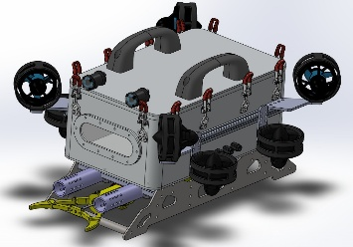 | 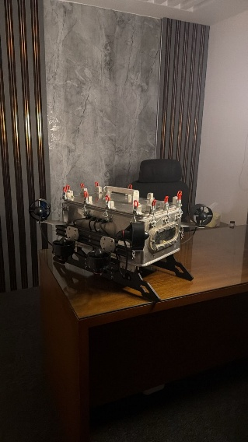
(a) | (b)
Fig. 1: (a) CAD model of HAUV 2.0; (b) Real-world implementation of HAUV 2.0.
As illustrated in Fig. 1, the compact structural layout improves mass distribution, underwater stability, and maneuverability while reducing drag and simplifying deployment preparation. The optimized buoyancy balancing system further enables smooth navigation, accurate positioning, and reliable mission execution across multiple autonomous tasks.

Capability-Oriented Mission Planning
For RoboSub 2026, Team BengalSub focuses on reliable execution of foundational navigation and precision-interaction missions that align closely with HAUV 2.0’s core capabilities in visual perception, stable maneuvering, and controlled actuation. Rather than aggressively pursuing all competition objectives, the team prioritizes a smaller but highly validated mission set to maximize operational consistency and subsystem reliability during autonomous execution.
- Heading Out and Begin Assessment: This mission serves as the primary objective and must be completed before all subsequent tasks are executed. HAUV 2.0 utilizes the YOLOv11 object detection model [1] and real-time image processing through the forward-facing Intel RealSense camera to identify the gate markers corresponding to either the Search & Rescue or Survey & Repair pathway. After detecting the correct marker, the vehicle autonomously aligns and navigates through the gate while storing the selected gate identity and vehicle pose information for the later Return Home mission. Upon successful traversal, HAUV 2.0 performs two complete roll revolutions to obtain additional mission points.
- Coin Flip: The Coin Flip task is prioritized due to its low operational complexity and reliable scoring potential. After ensuring the initial gate mission, HAUV 2.0 requests a coin flip to randomize its orientation. Using the VectorNav IMU and forward-facing Intel RealSense camera, the vehicle estimates its heading, stabilizes its orientation, re-aligns with the gate, and autonomously passes through before proceeding toward the Navigate the Channel mission.
- Navigate the Channel (Salom): In the Navigate the Channel mission which is our third priority, HAUV 2.0 performs autonomous navigation through the slalom-style obstacle arrangement using visual perception, localization, and real-time heading correction. After localizing the channel and adjusting its operating depth relative to the pipe structures, the vehicle centers itself between the red and white pipes and proceeds forward while maintaining stable trajectory control and robust underwater maneuverability.
- Deploy (Torpedoes): For the Deploy mission our fourth priority, HAUV 2.0 utilizes computer vision-based pose estimation and FLANN (Fast Library for Approximate Nearest Neighbors) [2] feature matching to identify and localize the target board in real time. Since rapid processing is critical for underwater operation, FLANN is employed to achieve efficient and reliable feature correspondence between the reference target and live camera frames. After estimating the target pose and alignment, the vehicle performs closed-loop positioning and autonomously deploys the torpedoes toward the designated target region.
- Bins: HAUV 2.0 initially utilizes the forward-facing camera to detect and approach the target bins. Once the vehicle reaches the target region, the downward-facing camera and VectorNav is used for precise localization and alignment with the two marker positions designated for payload deployment. After estimating the relative position of the markers, the system compensates for the spatial offset between the downward-facing camera and the dropping mechanism to ensure accurate payload release into the bins.
- Return Home: In the Return Home mission, HAUV 2.0 autonomously navigates back to the original gate used during the Heading Out and Begin Assessment task. Using the previously stored gate identity, vehicle pose information, and real-time visual feedback, the vehicle re-identifies the correct gate marker and passes through the same pathway to complete the mission.

Risk Assessment
To ensure reliable underwater operation and mission execution, potential risks associated with perception, localization, control, software integration, and hardware reliability were systematically analyzed during the development of HAUV 2.0. Appropriate mitigation strategies were incorporated to improve system robustness, operational safety, and overall mission reliability.
Table I
Risk Assessment And Mitigation Strategies
Risk Category | Impact | Mitigation
Localization Drift | Navigation error | Sensor fusion and visual correction
Poor Visibility | Detection failure | Image preprocessing and confidence checks
Thruster/Control Failure | Loss of maneuverability | PID tuning and subsystem testing
Software Failure | Control interruption | Modular ROS2 architecture and watchdogs
Power Failure | System shutdown | Power monitoring and mission planning
High Mission Complexity | Reduced reliability | Focus on validated core missions
Safety Risk | Vehicle damage | Kill switch and leak detection

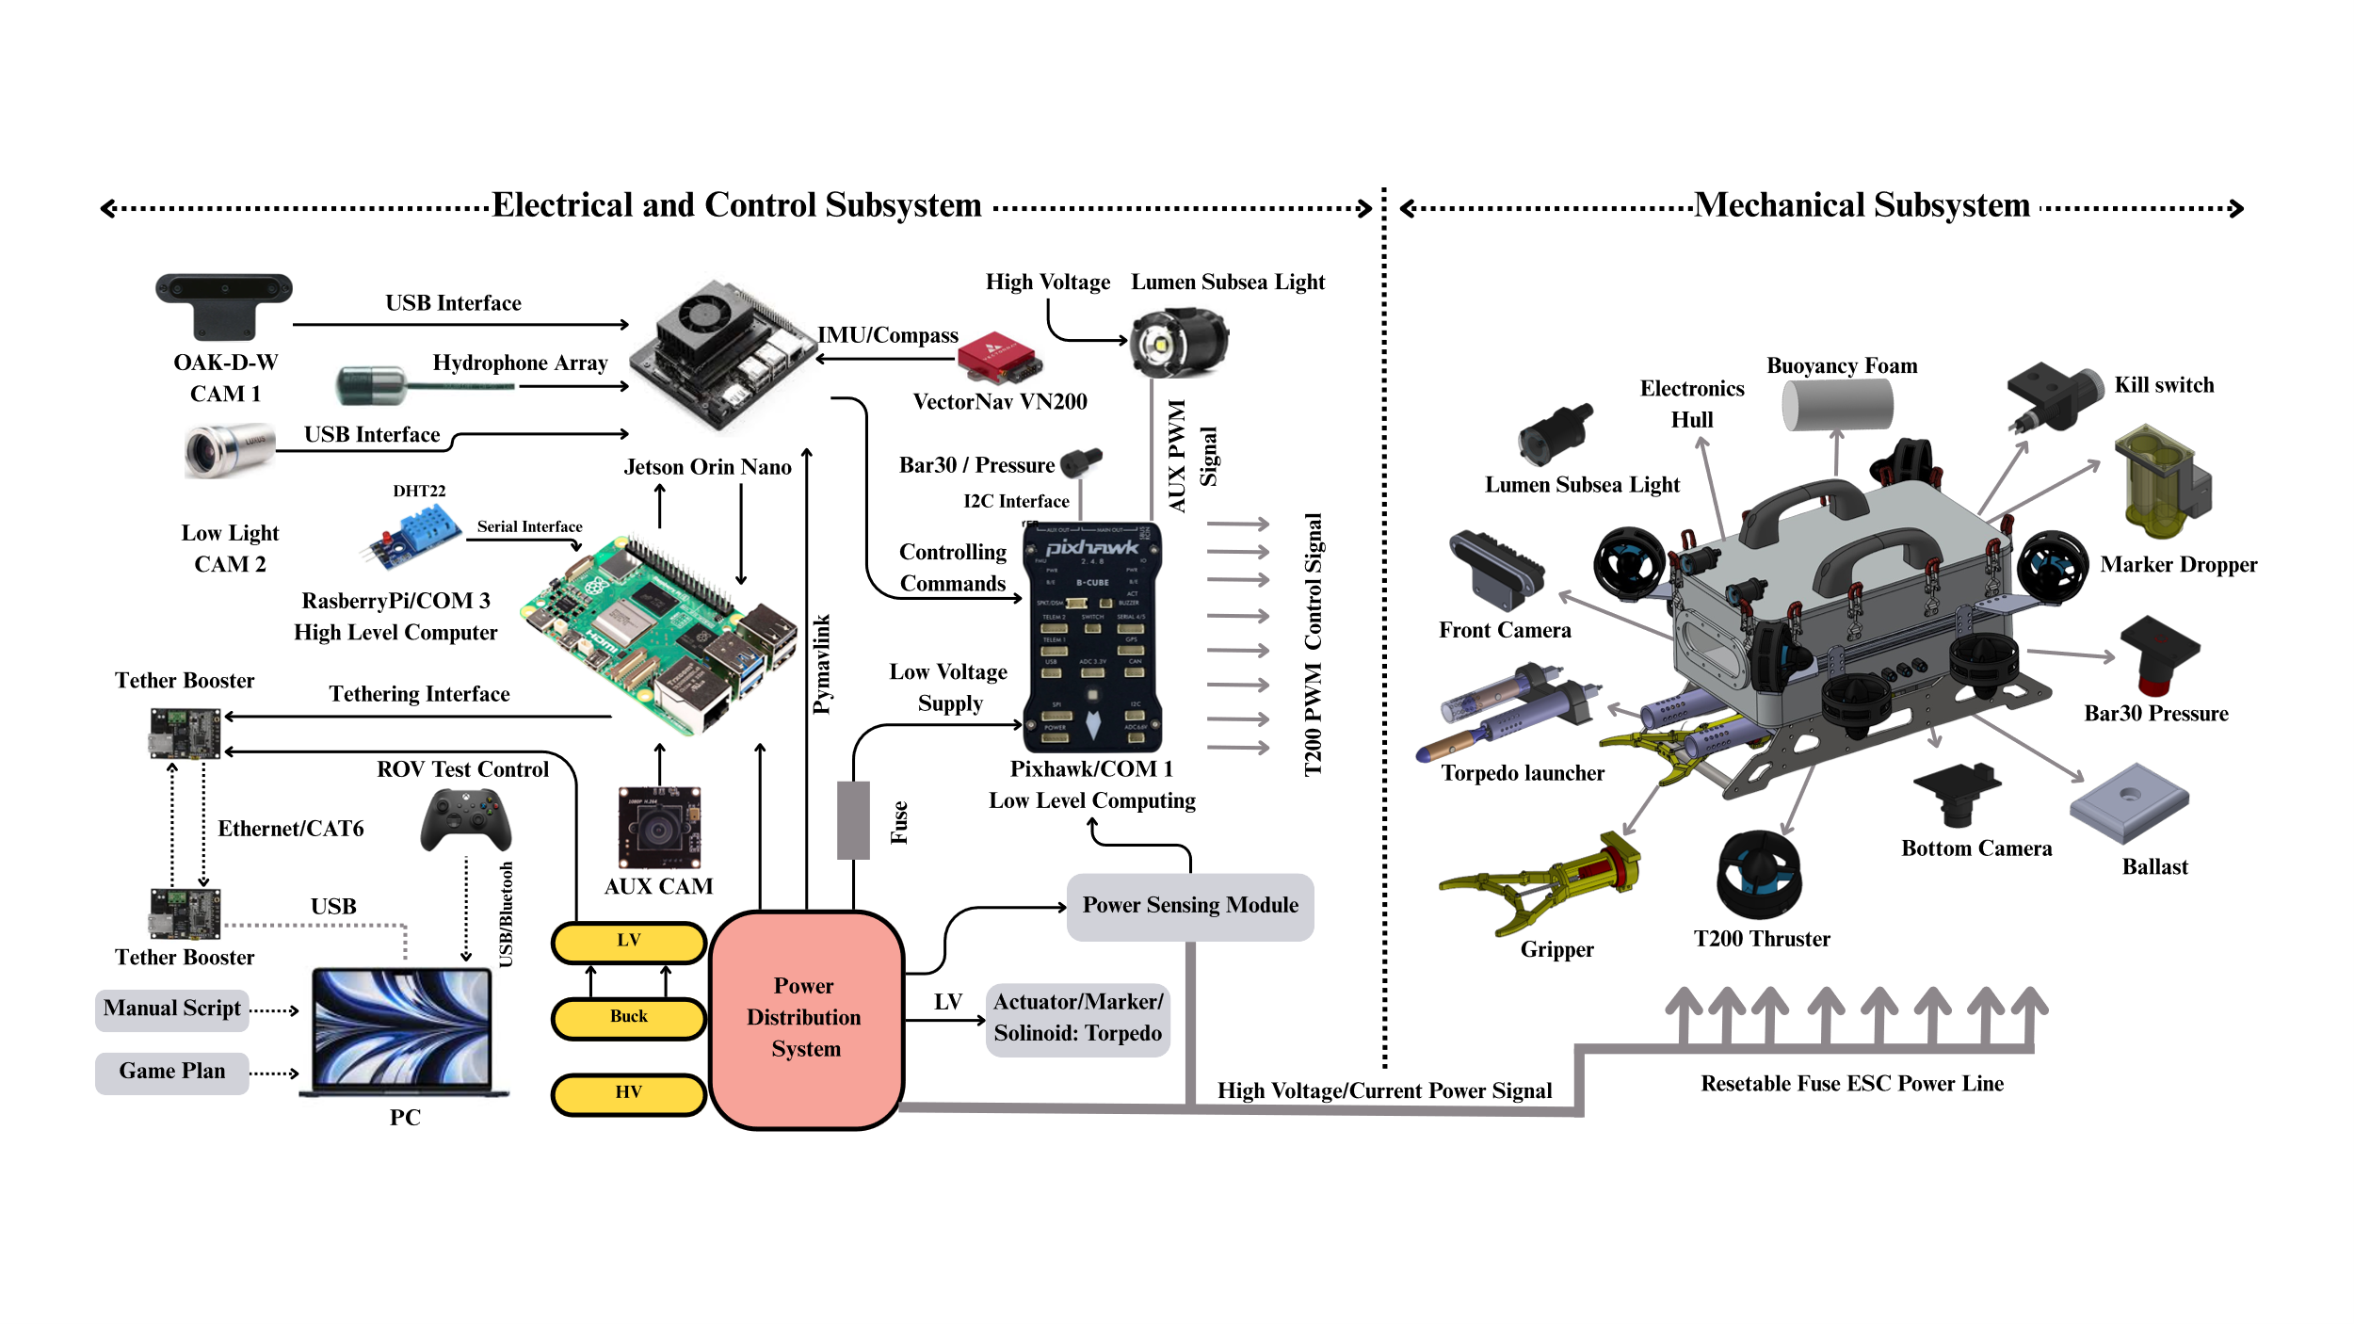
Design Strategy

Fig 1. HAUV 2.0 Hardware Design Overview.

HAUV 2.0 Mechanical Improvements
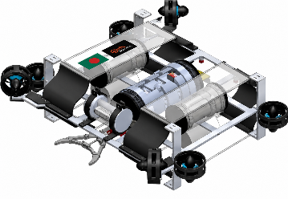 | 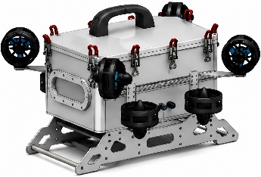
(a) | (b)
Fig. 2: 3D CAD renderings of the HAUV 2.0.
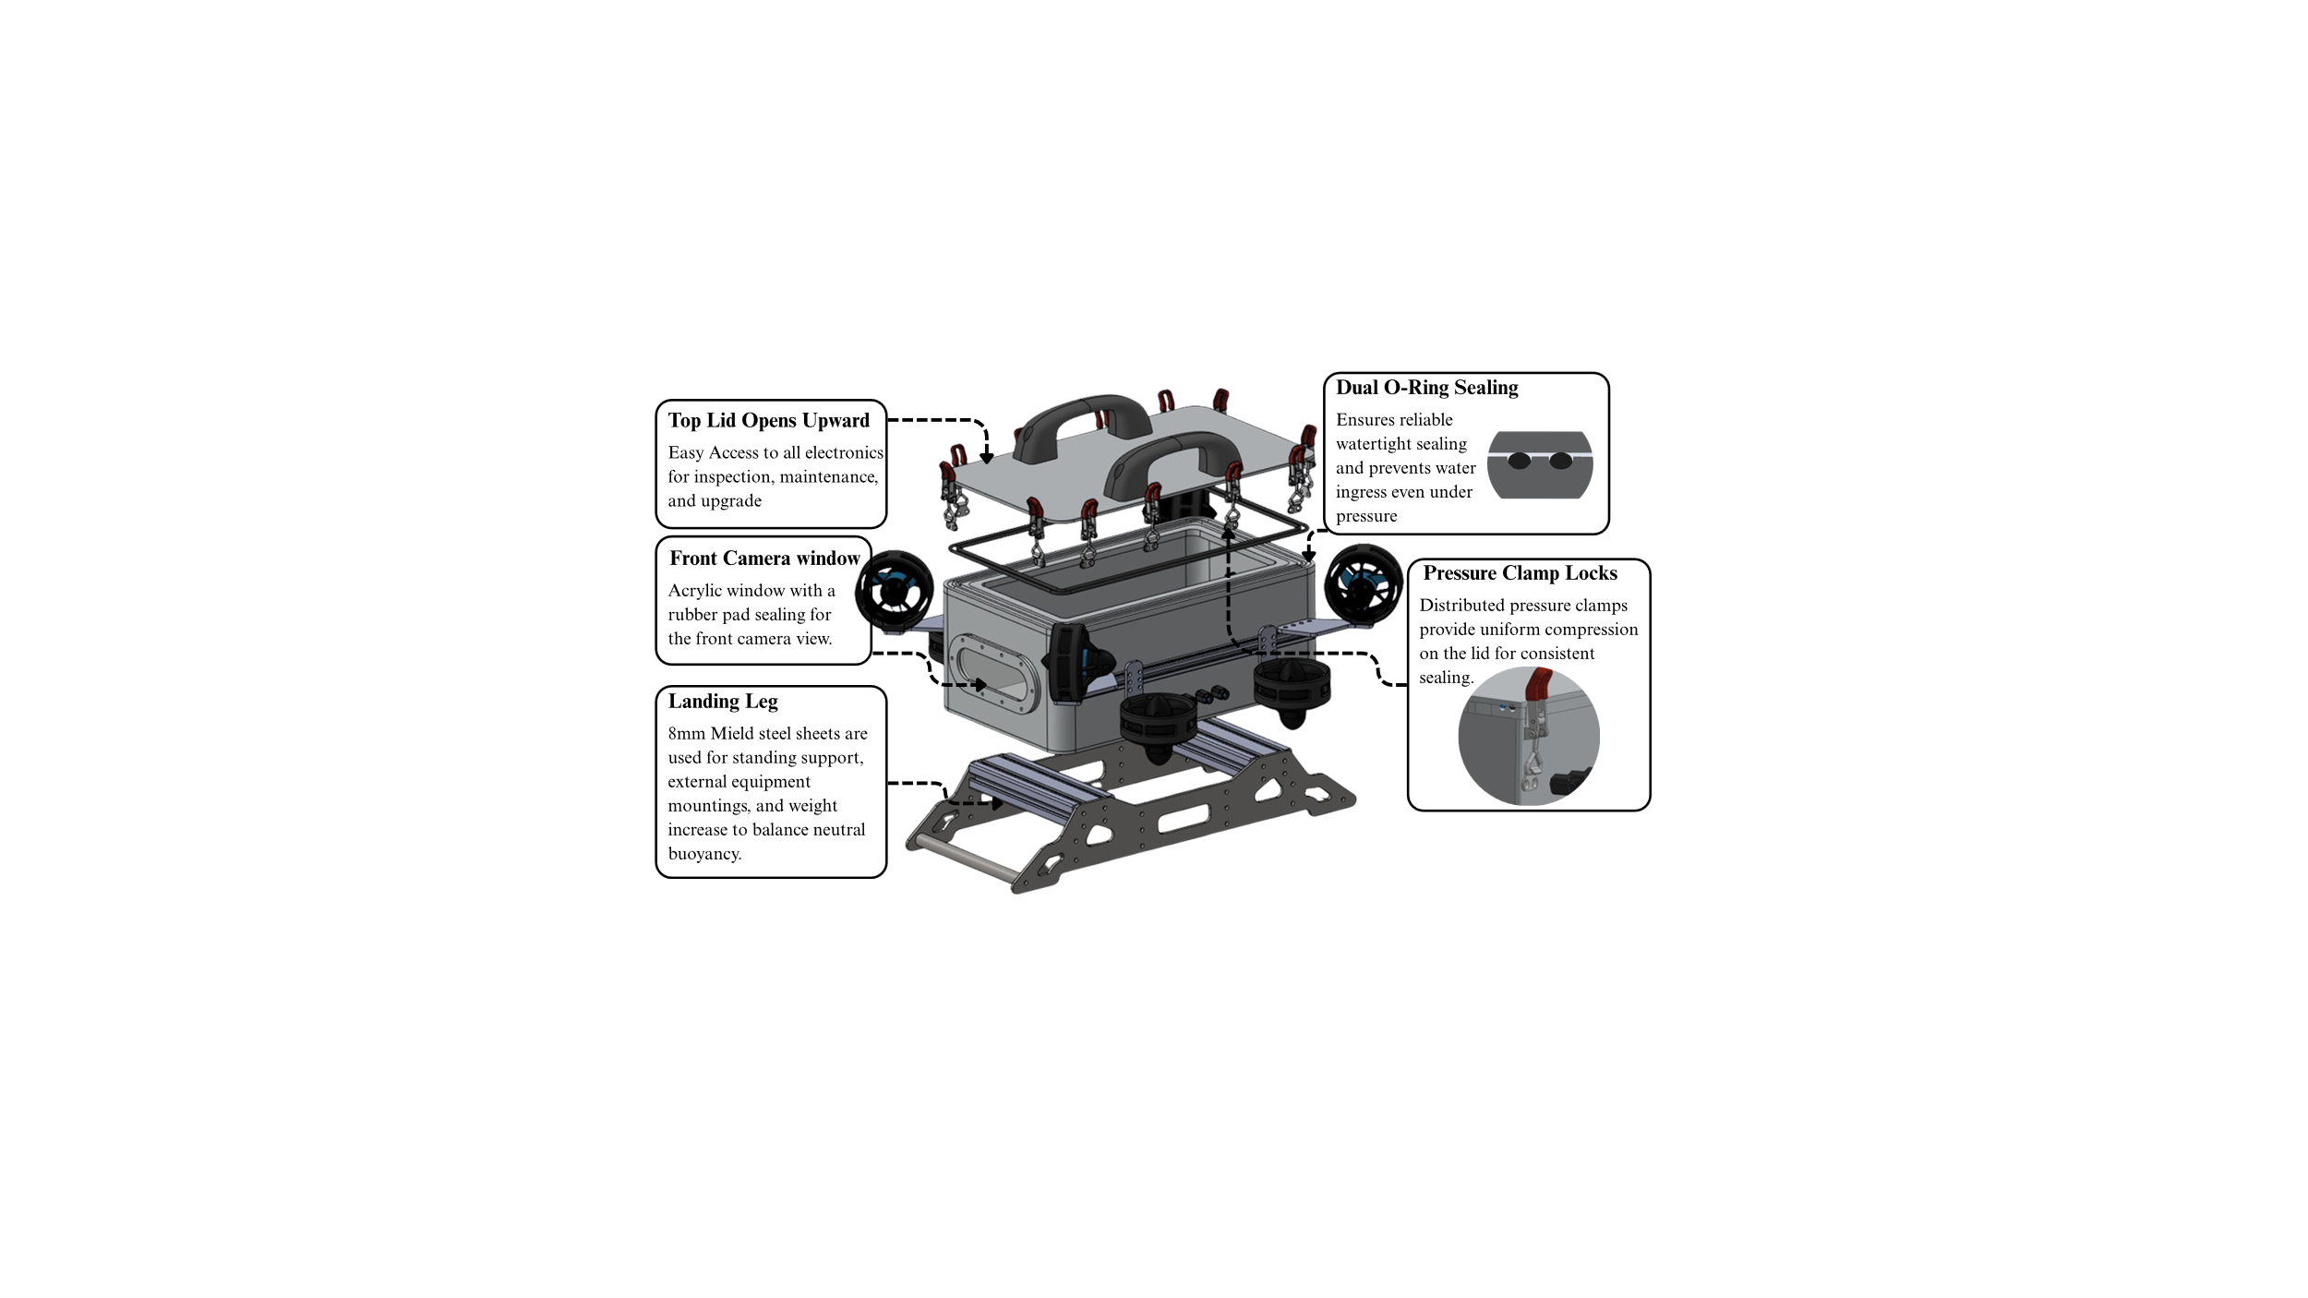
The mechanical architecture of HAUV 2.0 was redesigned based on operational experience from RoboSub 2025 testing of HAUV 1.0. The previous platform used multiple acrylic cylindrical enclosures mounted on an aluminum frame, as shown in Fig. 2(a). In contrast, HAUV 2.0 adopts a more compact and centralized structure shown in Fig. 2(b) to improve reliability, maintainability, and underwater stability. A comparison is given in the Table II.
Table II
Comparison Between HAUV 1.0 and HAUV 2.0
Parameter | Hangor 1.0 | Hangor 2.0
Electronics Housing | Multiple acrylic cylinders | Unified aluminum enclosure
Primary Seal Interfaces | Multiple | Single continuous O-ring
Structural Configuration | Distributed modular frame | Centralized compact frame
Cable Management | Distributed | Centralized
Maintenance Accessibility | Moderate | High
Leakage Risk | Higher | Reduced
Structural Rigidity | Moderate | Improved
Fig 4: Key design features to improve accessibility, reduce sealing risk, and weight balance
- Unified Electronics Enclosure:
To HAUV 2.0 utilizes a unified pressure-sealed electronics enclosure fabricated from 5 mm marine-grade aluminum. All major electronics, including the Jetson Orin Nano, Raspberry Pi 5, ESCs, power system, communication modules, and batteries, are integrated into a single enclosure shown in Fig. 3. The design reduces sealing interfaces and minimizes water ingress risks. A continuous rubber O-ring and locking clamp system provide reliable watertight sealing while simplifying cable management and maintenance accessibility.
- Structural Frame and Thruster Layout:
The structural frame was redesigned with a compact symmetric configuration to improve weight distribution, maneuverability, and 6-DOF stability. The symmetric T200 thruster arrangement shown in Fig. 4 enhances hover stability and rotational control during autonomous operations. The updated structure also improves rigidity and reduces subsystem mounting complexity.
- Improved Marker Dropper and Torpedo:
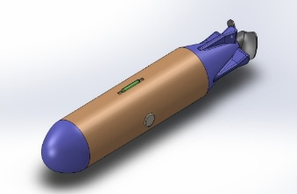 | 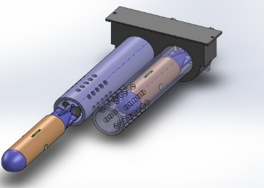
(a) | (b)
Fig. 5: (a) Torpedo; (b) Torpedo Launcher.
The torpedo launcher shown in Fig. 5(b) uses a compact dual-barrel mechanism with servo-actuated release control for reliable autonomous deployment. Lightweight corrosion-resistant materials were used to reduce payload weight while maintaining durability.
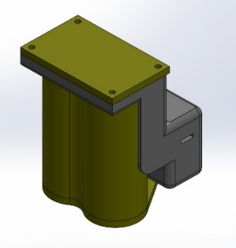 | 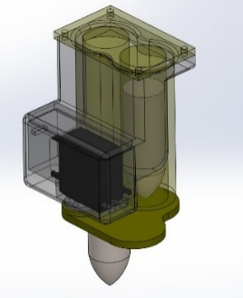
(a) | (b)
Fig. 6: (a) Outside view; (b) Inside view of marker dropper.
The marker dropper utilizes a compact servo-driven release mechanism integrated into the lower frame of the vehicle illustrated in Fig. 6. The system securely holds multiple markers while allowing accurate deployment during autonomous missions. Its modular structure also enables rapid reloading and maintenance.
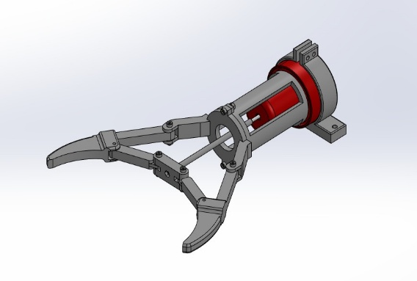
- Improved Grabber:
Fig. 7: Grabber.
HAUV 2.0 incorporates a lightweight servo-actuated grabber (Fig. 7) for underwater object manipulation. Mounted at the front of the vehicle, the grabber provides stable grasping capability while maintaining low drag and maneuverability. The mechanism supports reliable opening and closing operations integrated with the vehicle autonomy system.

HAUV 2.0 Electrical System
The template is used to format your paper and style the text. All margins, column widths, line spaces, and text fonts are prescribed; please do not alter them. You may note peculiarities. For example, the head margin in this template measures proportionately more than is customary. This measurement and others are deliberate, using specifications that anticipate your paper as one part of the entire proceedings, and not as an independent document. Please do not revise any of the current designations.

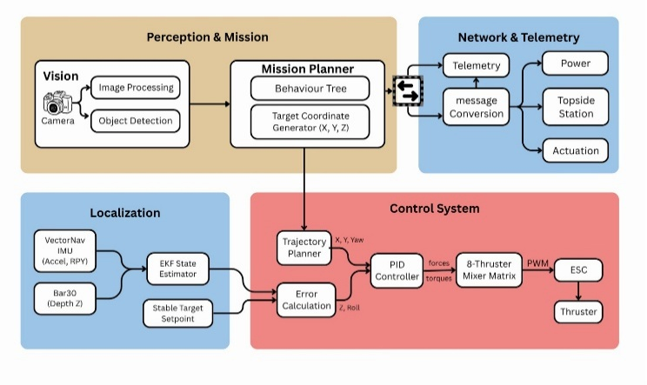
HAUV 2.0 Software Stack
Fig. 8: Software system design.
The software stack of HAUV2.0 has been significantly upgraded from the previous HAUV1.0 platform through the transition from a Python-based MAVLink pipeline to a fully modular ROS2-based architecture developed from scratch. The system utilizes ROS2 Humble on the Jetson Orin Nano and ROS2 Jazzy on the Raspberry Pi 5, improving scalability, robustness, and maintainability for future subsystem integration.
- Vision:
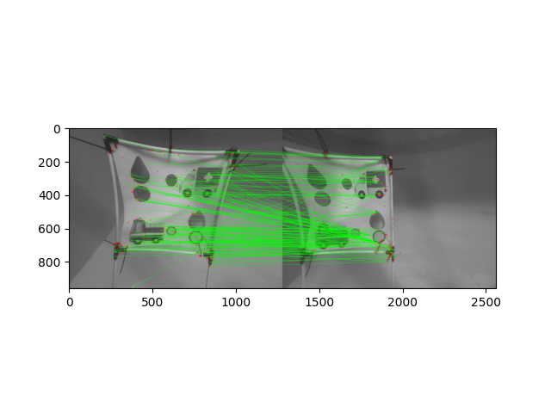
This year HAUV 2.0 incorporates an upgraded real-time underwater vision system using the YOLOv11 object detection model for robust detection of gates, markers, salom, and deployment targets under varying underwater conditions. The perception pipeline integrates FLANN-based feature matching for efficient pose estimation during precision tasks such as torpedo deployment (Fig. 8). Stereo RGB vision further enhances depth estimation and spatial awareness, enabling accurate positioning and autonomous navigation.
Fig. 8: Pose estimation via FLANN.
- Localization:
HAUV 2.0 employs a sensor-fusion-based localization framework for robust underwater state estimation in GPS-denied environments. An Extended Kalman Filter (EKF) fuses data from a VectorNav IMU and Blue Robotics Bar30 pressure sensor to estimate the vehicle’s pose, orientation, and motion states. This year we incorporated Physics-informed constraints (Appendix C) to enhance motion consistency and system stability, while adaptive disturbance filtering and state correction ensure reliable localization and stable autonomous navigation.
- Control System:
HAUV 2.0 utilizes an improved closed-loop PID-based control system for stable and precise underwater maneuvering. Compared to the previous platform, the vehicle weight and onboard system complexity increased, requiring optimization of thruster allocation and controller tuning to compensate for updated mass distribution and inertia characteristics. Using feedback from the VectorNav IMU, Bar30 pressure sensor, and vision-based localization pipeline, the control system regulates depth, orientation, and vehicle motion to achieve improved hover stability, smoother trajectory tracking, and reliable autonomous operation under dynamic underwater conditions.
Fig. 9: Control System block diagram.
- Mission Planner:
HAUV 2.0 utilizes a Behavior Tree (BT)-based mission planning framework for modular, reactive, and fault-tolerant autonomous operation. The planner is implemented using the BehaviorTree.CPP framework and integrated with the onboard ROS2 ecosystem for real-time task execution and decision-making. The mission tree consists of composite, decorator, condition, and action nodes that manage mission sequencing, recovery behaviors, and runtime state transitions. Condition nodes monitor critical system states such as battery health, localization status, obstacle clearance, and depth constraints, while action nodes execute navigation, hovering, payload deployment, and emergency recovery tasks. The framework supports ROS2 action/service integration and BehaviorTree.CPP XML-based mission deployment, enabling scalable and maintainable autonomous mission execution.

Testing Strategy

Mechanical Testing
The mechanical testing strategy of HAUV 2.0 focused on validating enclosure integrity, sealing reliability, structural stability, and underwater operational performance under repeated field-testing conditions. To address the sealing-related limitations observed in Hangor1.0, the unified aluminum enclosure underwent repeated vacuum leak tests, dry sealing inspections, and prolonged underwater submersion tests to evaluate resistance against water ingress. Dual O-ring interfaces and pressure-locking mechanisms were additionally validated through multiple assembly-disassembly cycles to ensure consistent sealing performance during maintenance operations.
Repeated dry and underwater testing were conducted to validate structural stability, actuation reliability, and operational consistency, as described in Appendix A.
Further mechanical validation included buoyancy balancing, center-of-mass verification, structural rigidity assessment, and thruster mounting integrity testing under dynamic maneuvering conditions. Pool-based testing was also conducted to evaluate hover stability, maneuverability, and overall operational reliability during autonomous mission execution.

Electrical Testing
- Use either SI (MKS) or CGS as primary units. (SI units are encouraged.) English units may be used as sec ondary units (in parentheses). An exception would be the use of English units as identifiers in trade, such as “3.5-inch disk drive”.
- Avoid combining SI and CGS units, such as current in amperes and magnetic field in oersteds. This often leads to confusion because equations do not balance dimensionally. If you must use mixed units, clearly state the units for each quantity that you use in an equation.
- Do not mix complete spellings and abbreviations of units: “Wb/m2” or “webers per square meter”, not “webers/m2”. Spell out units when they appear in text: “. . . a few henries”, not “. . . a few H”.
- Use a zero before decimal points: “0.25”, not “.25”. Use “cm3”, not “cc”. (bullet list)

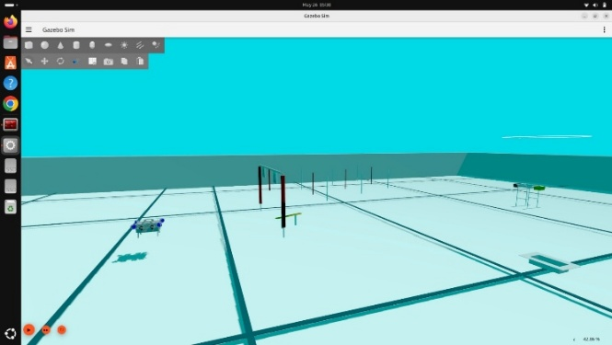
Software Testing
Fig. 10: Gazebo simulation testing.
The software testing strategy of HAUV 2.0 focused on validating communication reliability, subsystem integration, and autonomous mission execution within the hybrid ROS2 architecture. Since the system utilizes ROS2 Jazzy on the Raspberry Pi 5 and ROS2 Humble on the Jetson Orin Nano, cross-version ROS2 bridge communication was extensively tested and validated using Eclipse Cyclone Data Distribution Service (DDS). Individual software modules additionally underwent unit testing, subsystem-level validation, and peer-review-based code verification to improve software robustness and maintainability. For full-system analysis and validation, Gazebo Harmonic simulation was employed to evaluate sensor integration, localization, control behavior, and mission-level autonomy prior to real-world deployment, as illustrated in Fig. 10. These simulation-based tests (observations are summarized in Appendix C) enabled safe iterative debugging, performance evaluation, and autonomous mission verification before underwater field testing.

Acknowledgment
The preferred spelling of the word “acknowledgment” in America is without an “e” after the “g”. Avoid the stilted expression “one of us (R. B. G.) thanks ...”. Instead, try “R. B. G. thanks...”. Put sponsor acknowledgments in the unnumbered footnote on the first page.

References
- Peiyuan Jiang, Daji Ergu, Fangyao Liu, Ying Cai, Bo Ma, A Review of Yolo Algorithm Developments, Procedia Computer Science, Volume 199, 2022, Pages 1066-1073, ISSN 1877-0509.
- Cong Fu, Chao Xiang, Changxu Wang, and Deng Cai. 2019. Fast approximate nearest neighbor search with the navigating spreading-out graph. Proc. VLDB Endow. 12, 5 (January 2019), 461–474.
- P.J.A. Alphonse, K.V. Sriharsha, Depth estimation from a single RGB image using target foreground and background scene variations, Computers & Electrical Engineering, Volume 94, 2021, 107349, ISSN 0045-7906.

Appendix A
Vacuum and Leak Testing

Vacuum Leak Testing
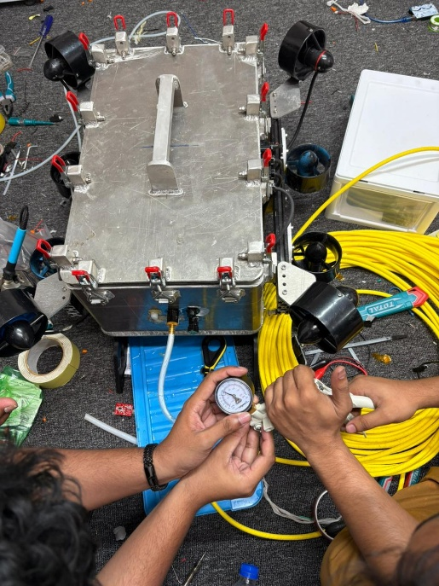
To validate enclosure sealing integrity prior to underwater deployment, Hangor 2.0 undergoes repeated vacuum leak testing procedures throughout subsystem integration and pre-mission inspection stages. The test is conducted to identify potential leakage paths around enclosure joints, O-ring interfaces, penetrators, and cable sealing regions before exposing the vehicle to underwater operating conditions.

Fig. 19: Vacuum Leak Testing in air.

During testing, the unified aluminum enclosure is fully assembled with all penetrators, sealing interfaces, and pressure-locking clamps installed under operational configuration. A controlled vacuum is generated inside the enclosure using an external vacuum pump connected through a dedicated testing port. Internal pressure variation is continuously monitored over a fixed observation period to evaluate sealing consistency and enclosure integrity.
The dual O-ring sealing interfaces and distributed pressure-locking mechanism were repeatedly validated through multiple assembly-disassembly cycles to ensure reliable compression performance and sealing repeatability during field maintenance operations. Vacuum testing additionally enabled rapid identification of improper seal seating, loose penetrator interfaces, and minor assembly defects prior to underwater operation.
Repeated validation demonstrated stable internal pressure retention and improved sealing reliability compared to the previous multi-enclosure architecture used in Hangor 1.0.

Underwater Leak Testing
Following vacuum validation, Hangor 2.0 undergoes prolonged underwater leak testing to evaluate enclosure integrity and operational reliability under submerged conditions. The testing procedure focuses on validating sealing performance, penetrator reliability, and enclosure durability during extended underwater exposure.
The fully integrated vehicle is submerged under static conditions for extended durations while monitoring internal electronics compartments for evidence of water ingress, humidity variation, or sealing degradation. Additional dynamic testing is conducted during maneuvering operations to evaluate sealing stability under vibration, thrust loading, and underwater motion.
Special attention is given to:
  - O-ring sealing interfaces,
  - pressure-locking clamps,
  - cable penetrators,
  - camera windows,
  - and mechanical mounting interfaces.

Repeated pool-based validation confirmed stable enclosure performance and no observable leakage during operational testing. The centralized single-enclosure architecture significantly reduced potential ingress points and simplified leak inspection procedures compared to the previous distributed enclosure configuration.
These testing procedures played a critical role in validating the reliability-centered redesign strategy implemented in Hangor 2.0 for RoboSub competition deployment.

Add Images of AUV underwater

CFD-Based Hydrodynamic Analysis
Computational Fluid Dynamics (CFD) analysis was conducted to evaluate the hydrodynamic behavior, drag characteristics, and flow distribution of Hangor 2.0 under forward underwater motion. The analysis focused on identifying flow separation regions, pressure concentration zones, and structural disturbances generated by the redesigned vehicle architecture and externally mounted mission mechanisms.
The simulation was performed in SolidWorks Flow Simulation using an external turbulent flow model with seawater as the working fluid medium. A steady-state forward velocity condition was applied along the positive X-axis direction to analyze drag force and flow behavior during autonomous underwater navigation.
The CFD study primarily evaluated:
  - frontal drag characteristics,
  - wake propagation,
  - velocity distribution,
  - and turbulence generation around the vehicle structure.

Velocity cut plots along the X-axis were generated to visualize flow uniformity and wake behavior surrounding the enclosure, frame, and propulsion system. The results indicated improved flow continuity around the centralized enclosure architecture with reduced turbulence regions compared to the previous distributed mechanical configuration. The compact frame geometry additionally reduced exposed structural disturbances and improved overall hydrodynamic efficiency during forward motion.

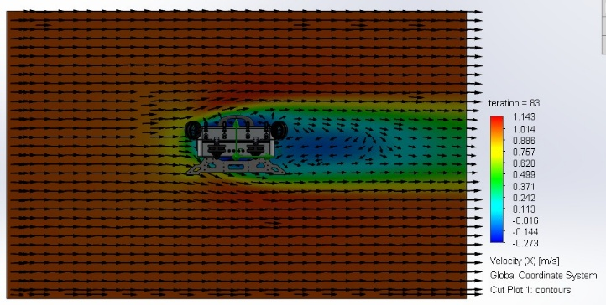 | 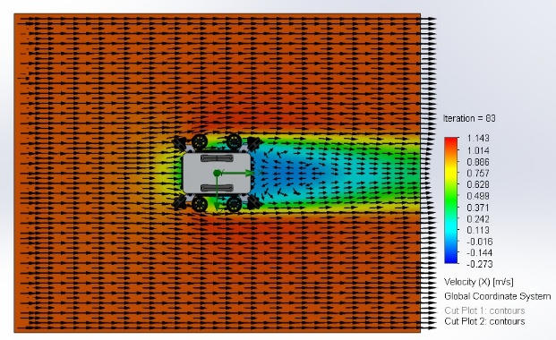
(a) | (b)

Fig. 20: Cut plot of drag force for forward velocity of the vehicle. (a) Side view, (b) Top view
The drag force generated along the X-axis was evaluated using global force goals within the simulation environment. The analysis demonstrated reduced frontal drag characteristics due to the smoother enclosure profile and centralized subsystem integration implemented in Hangor 2.0.

Parameter | Value
Simulation Software | SolidWorks Flow Simulation
Analysis Type | External Flow
Flow Regime | Turbulent
Fluid Medium | Sea Water
Inlet Velocity | 1 m/s
Flow Direction | Positive X-axis
Gravity | Enabled
Mesh Type | Automatic Cartesian Mesh
Simulation Type | Steady-State
Evaluated Outputs | Drag Force, Velocity Cut Plot, Pressure Distribution

CFD Analysis of Torpedo Launcher and Marker Dropper
Additional CFD analysis was conducted on the torpedo launching system and marker dropping mechanism to evaluate their influence on vehicle hydrodynamics and localized flow disturbances during forward motion.

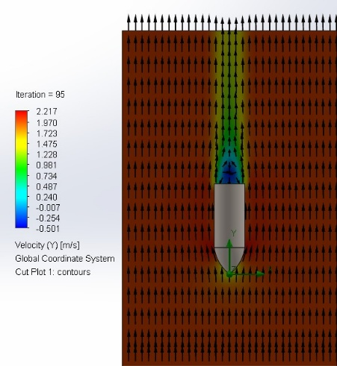 | 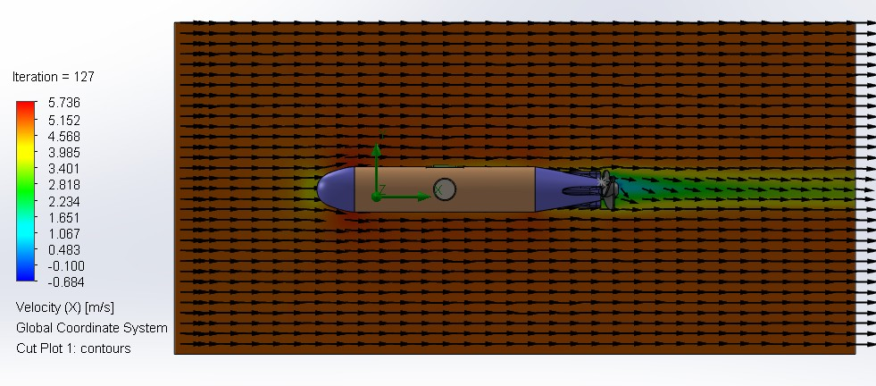
(a) | (b)

Fig. 21: CFD drag force analysis of (a) marker, (b) Torpedo using SolidWorks

The torpedo launcher, positioned within the frontal lower section of the vehicle, was analyzed to observe wake interaction and pressure concentration around the launcher barrels during forward operation. Velocity cut plots indicated localized turbulence generation near the launcher structure; however, the compact integration minimized significant disturbance to the primary vehicle flow profile and forward camera visibility region.
Similarly, the marker dropping mechanism was evaluated to study its effect on underside flow behavior and structural drag contribution. The streamlined mounting arrangement reduced excessive wake formation beneath the vehicle while maintaining stable flow distribution around the lower frame structure.
The CFD analysis confirmed that the integration of mission-specific mechanisms introduced minimal impact on overall hydrodynamic performance while maintaining operational functionality required for RoboSub mission execution.

Appendix B

Appendix C.
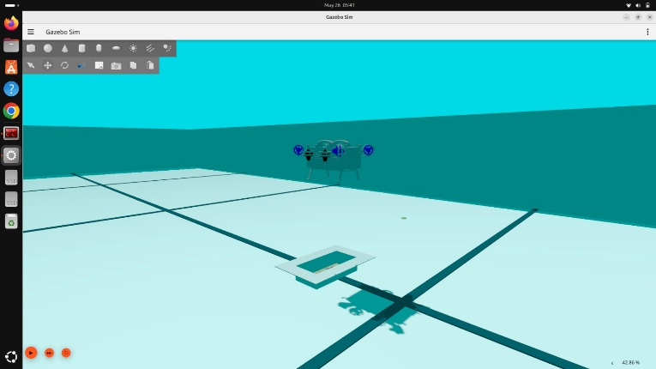
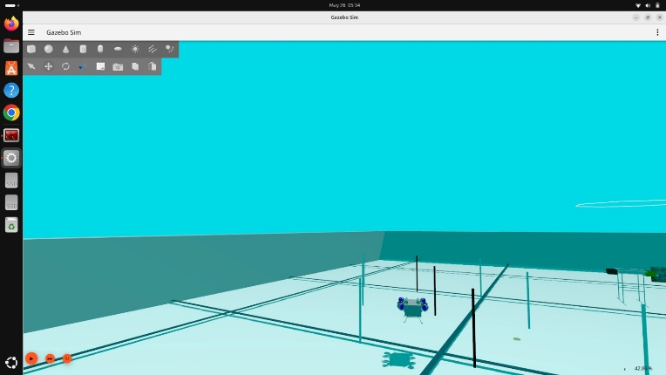
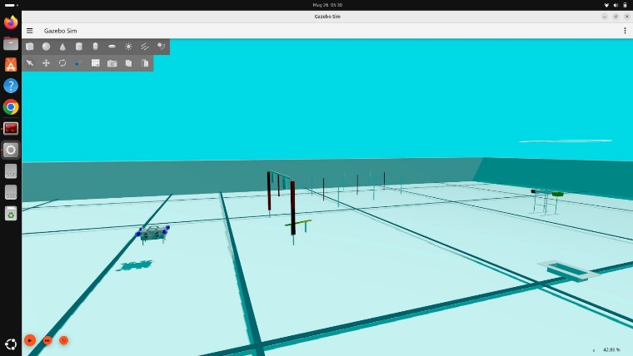
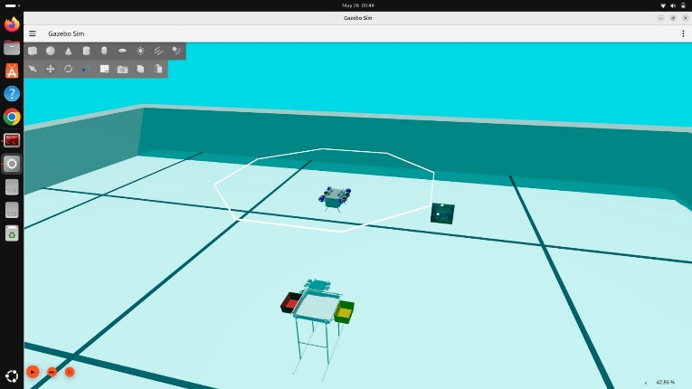
Software Simulation
Fig. 20

Detection Results
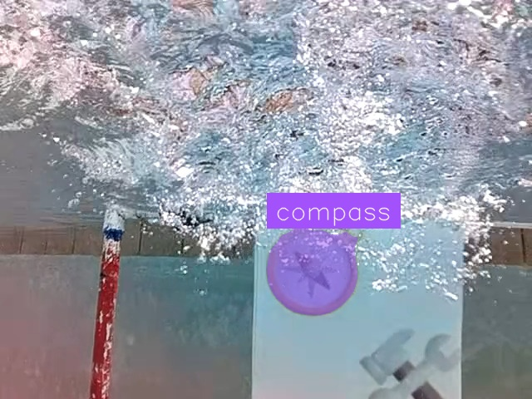
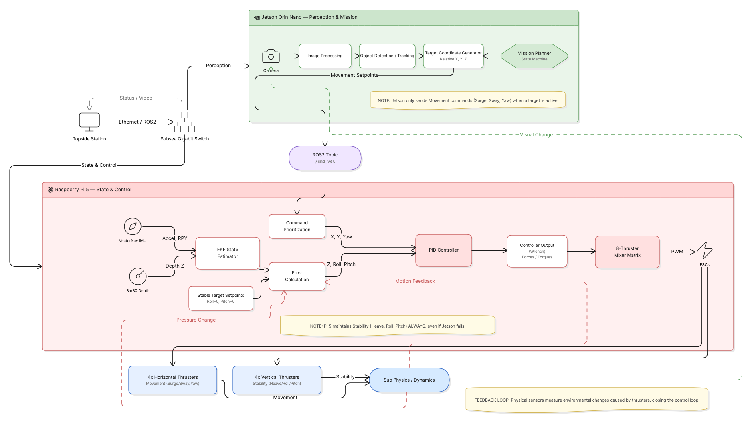
Software System Architecture
Fig. 21
Appendix D
Electrical Testing Plan

Category | Items
Power System | 1) Stable power distribution to all subsystems  2) Stable 5 V, 12 V, and 24 V outputs  3) Continuous operation under full system load  4) Power monitoring and voltage validation
Thruster and Kill System | 1) Kill switch disables thrusters immediately  2) System recovery after kill-state transition  3) Individual thruster response validation
Sensors | 1) IMU data acquisition and validation  2) Bar30 pressure sensor depth readings  3) Camera stream and synchronization verification
Communication | 1) ROS2 communication between Jetson Orin Nano and Raspberry Pi 5  2) Cross-device topic synchronization  3) Stable telemetry transmission
Telemetry | 1) Live system monitoring  2) Sensor and localization data visualization  3) Internal pressure and voltage monitoring
Actuation | 1) Torpedo deployment validation  2) Servo and actuator response testing
Safety System | 1) Leak detection monitoring  2) Emergency shutdown validation  3) Recovery behavior testing

Hardware Testing

Test/Simulation | Description
Preliminary Leak Test | The unified aluminum enclosure was vacuum-tested and submerged for extended durations to validate sealing reliability and resistance against water ingress.
Buoyancy and Balance Test | The vehicle underwent buoyancy balancing and center-of-mass verification to ensure stable underwater hovering and maneuverability.
Thruster Mounting Test | Thruster mounting structures were tested under dynamic operation to validate rigidity and vibration resistance.
Bench Test | Prior to pool deployment, all thrusters, sensors, cameras, and onboard systems were sequentially tested to verify communication and operational readiness.
Pool Test | Pool-based testing validated depth control, hover stability, navigation performance, and autonomous mission execution under real underwater conditions.
Endurance Test | Long-duration underwater operation was performed to evaluate thermal stability, power consumption, and operational reliability.

Software Test Plan

Component/Capability | Description | Methodology | Timeline
Sensor Drivers | Validation of sensor communication and ROS2 integration | Individual driver testing and hardware validation | March 2026
Localization and Control | Testing of EKF-based localization and PID control | Simulation and pool-based validation using logged sensor data | March – April 2026
Vision System | Validation of YOLOv11 perception and FLANN feature matching | Simulation and underwater testing under varying lighting conditions | April 2026
Mission Planner | Testing of Behavior Tree-based autonomous mission execution | Simulation-based and in-water mission trials | April – May 2026
ROS2 Hybrid Architecture | Validation of ROS2 Humble and Jazzy bridge communication | Cross-device communication and integration testing | April 2026
Autonomous Navigation | Verification of waypoint navigation and obstacle handling | Gazebo Harmonic simulation and pool testing | May 2026
Actuation System | Testing of torpedo deployment and actuator control | Manual and autonomous deployment testing | May – June 2026
Full System Integration | End-to-end validation of all autonomous subsystems | Combined simulation and underwater mission testing | June 2026

Appendix E
Component Lists

Component | Vendor | Model / Type | Specifications | Custom / Purchased | Year | Cost
Buoyancy Control | Blue Robotics | Buoyancy Foam R3318 | 6 pieces | Purchased | 2025 | $300
Frame | Local | Custom Aluminum Modular | Custom design | Custom | 2025 | $120
Waterproof Housing | Local | Custom enclosure | Acrylic tube with rubber sealer | Custom | 2025 | $130
Waterproof Connectors | Local | ABS | ABS filament | Custom | 2025 | $20
Frame Anodizing | Rainbow Gloss Black (39) | Black | Coating finish | Purchased | 2025 | $9
Thrusters | ROV Maker | T200 Brushless Thruster | High thrust underwater motor | Purchased | 2025 | $1200
Motor Control | Blue Robotics | BR-100344 ESC | Electronic Speed Controllers | Purchased | 2025 | $342
Low-Level Control | Robotics Bangladesh | Pixhawk Flight Controller | 32-bit Cortex-M4 ARM processor | Purchased | 2025 | $120
Actuators | Robotics Bangladesh | MG996R | 180-degree servo motor | Purchased | 2025 | $14
Battery | Eee Tech | LiPo 4S 14.8V 10000mAh 45C | High discharge battery | Purchased | 2025 | $200
Converter | Robotics Bangladesh | Buck Converter | 5–40V to 1.2–3.6V step-down | Purchased | 2025 | $10
CPU | Nvidia | Jetson Orin Nano | 6-core CPU, 1024-core GPU, 20 TOPS | Purchased | 2025 | $600
Internal Comm Network | N/A | CAN, MAVLink | Communication protocols | N/A | 2025 | N/A
External Comm Interface | BRB | Ethernet CAT6 | High-speed data link | Purchased | 2025 | $10
Programming Language 1 | N/A | C++ | System programming | N/A | 2025 | N/A
Programming Language 2 | N/A | Python | AI & scripting | N/A | 2025 | N/A
Compass and IMU | VectorNav | VN200 | GPS-aided 9-axis high-precision IMU | Purchased | 2025 | $3500
Cameras | Luxonis | OAK-D-W | 12 MP RGB camera module with autofocus | Purchased | 2025 | $649
Hydrophones | Aquarian Audio | H1a | 4.5mm OD hydrophone | Purchased | 2025 | $366
Manipulator | BengalSub | Custom | ABS + TPU custom gripper | Custom | 2025 | $50
Algorithms: Vision | N/A | YOLO V11 | Real-time object detection | N/A | 2025 | N/A
Algorithms: Acoustics | N/A | TDoA | Time Difference of Arrival | N/A | 2025 | N/A
Algorithms: Localization/Mapping | N/A | ROS2 | Robot operating system stack | N/A | 2025 | N/A
Open Source Software | N/A | ROS, Gazebo | Simulation & robotics frameworks | Open Source | 2025 | N/A
Team Size | N/A | N/A | 29 people | N/A | 2025 | N/A
HW/SW Expertise Ratio | N/A | N/A | 2:1 | N/A | 2025 | N/A
Testing Time: Simulation | N/A | N/A | 280 hours | N/A | 2025 | N/A
Testing Time: In-Water | N/A | N/A | 25 hours | N/A | 2025 | N/A

Appendix F
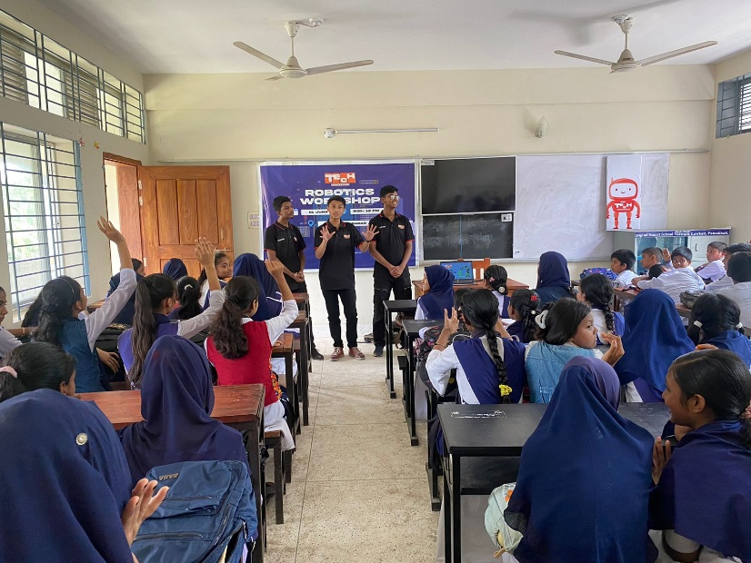
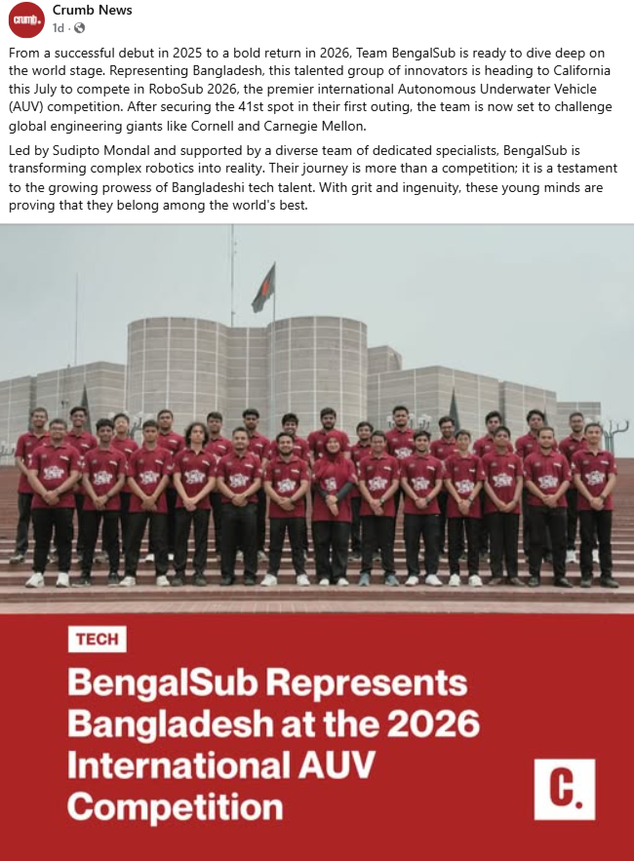
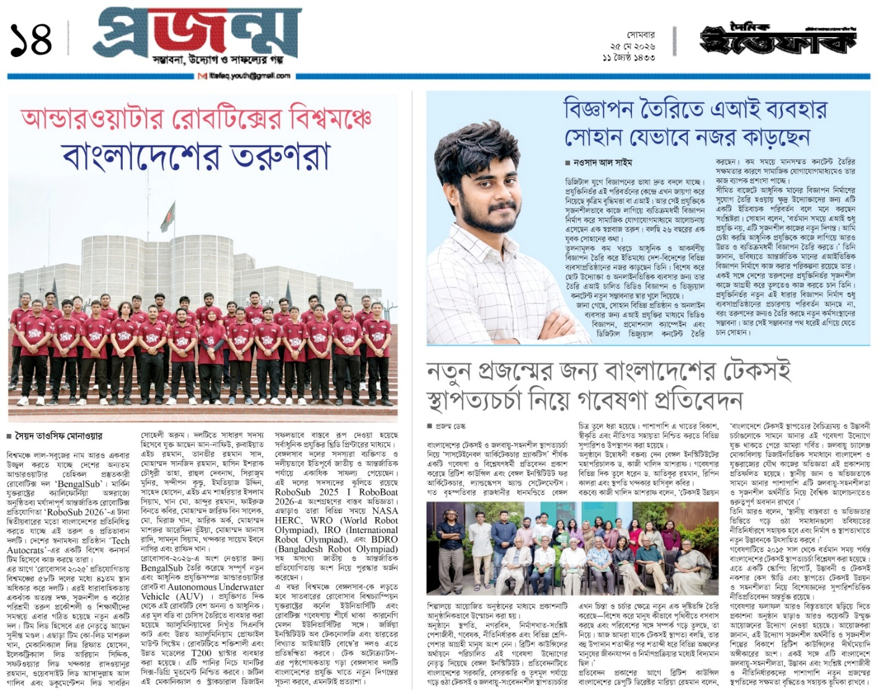
Community Outreach

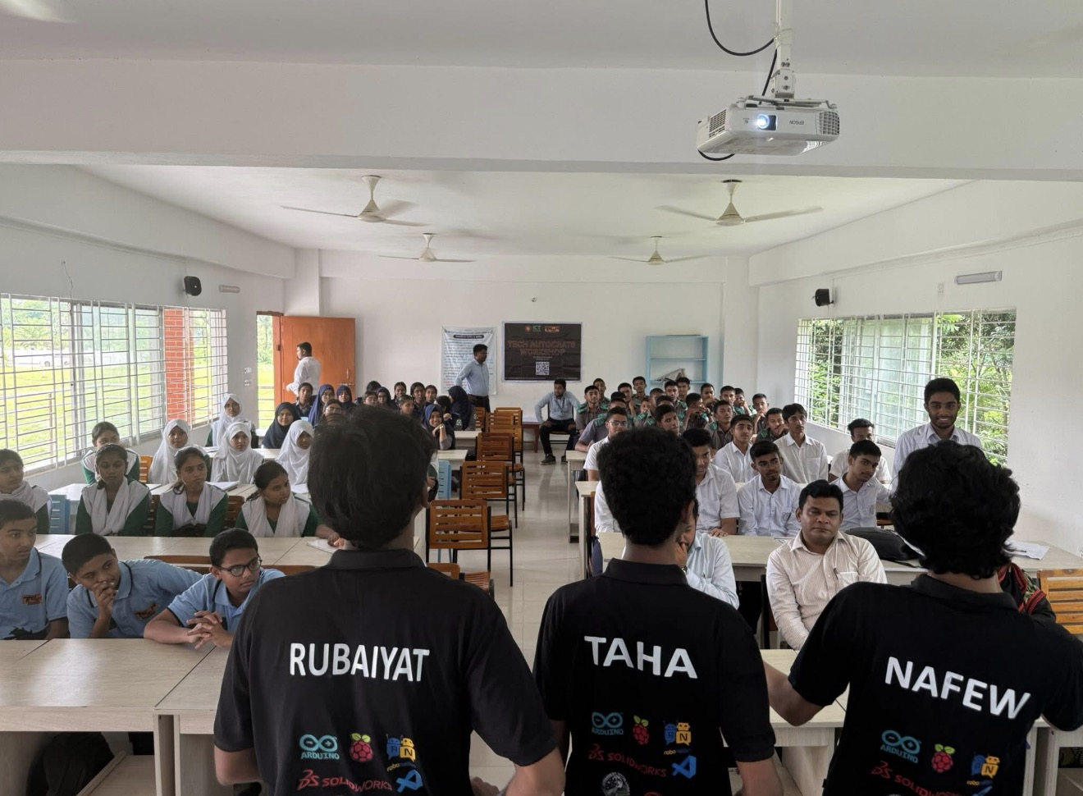
Fig. 24

Appendix G
Tools and Equipments

1) Electrical Equipment
  - Solder gun and stand
  - Solder wire
  - Wire strippers (standard and AWG precision)
  - Ethernet cables and LAN spool
  - HDMI cables
  - Micro USB cables for screens
  - Test screen
  - Multimeter
  - Spare, charged Li-Po batteries
  - Battery chargers (Li-Po compatible)
  - Extension cords and power strips
  - Screwdrivers (various sizes)
  - USB extenders and hubs
  - Scissors
  - USB ASP programmer
  - Glue gun and glue sticks
  - Arduino Uno boards with cables
  - Spare ATmega and CAN ICs
  - Duct tape and insulation tape
  - Jumper wires
  - Single-strand and AWG wires for harnessing
  - Mouse and keyboard
  - Heat shrinks tubing and heat gun
  - Crimping tools and connectors
  - XT60, XT30 connectors
  - Digital oscilloscope (for signal debugging)
  - Bench power supply
  - PDB test board
  - USB-to-UART interfaces
  - Hot air rework station (for PCB repairs)

2) Mechanical Equipment
  - Allen key and spanner set
  - Precision screwdrivers (PSD)
  - Drill machine with assorted bits
  - Epoxy resin, mixing cups, sticks
  - Cardboard, tissue, chalk for layout work
  - Duct tape, insulation tape
  - Zip ties (various sizes)
  - Rope for handling and lowering AUV
  - Nuts, bolts, washers (stainless steel preferred)
  - Buoyancy foam and floats
  - Mini hacksaw and blade replacements
  - Scissors and utility knife
  - Calipers and measuring tape
  - Sandpaper for edge finishing
  - Thread locker for critical fasteners
  - Ballast weights and mounting straps

3) Testing and Integration Equipment
  - Water tank or access to pool for testing
  - Fathom ROV Tether and slip ring.
  - Kill switch test harness
  - Tether booster modules
  - ROS2 Jazzy and Humble
  - Jetson Orin Nano and Raspberry Pi 5 for integration testing
  - Eclipse Cyclone DDS
  - Arduino and ESP32 microcontroller
  - Cameras (Intel Real Sense D455, low-light USB) for vision pipeline validation
  - Spare thrusters and ESCs for quick swap during pool tests
  - Digital scale for weight checks
  - Leak detection sensors and vacuum pump for hull testing

